**Task 1:**

**Code:**

a=0;b=2;

ezplot('0.2 + 2.*x + 90.*x.^2 - 120.*x.^3 + 25.*x.^4', [a, b]), hold on

approx = zeros(1,7); %initialize vector of results

for j = 1:7

n = 2^j;

x = b*(0:1/n:1);

plot(x, 0.2 + 2.*x + 90.*x.^2 - 120.*x.^3 + 25.*x.^4, 'r')

weights = [1, 2*ones(1,n-1), 1];

approx(j) = b/(2*n)*(0.2 + 2.*x + 90.*x.^2 - 120.*x.^3 + 25.*x.^4)*weights';

end

disp('Using Trapezoidal Rule')

disp(' n Approximation')

for j = 1:7

disp(['n = ', num2str(2^j, '%d'), ' ', num2str(approx(j), '%1.10f')])

end

**Output:**

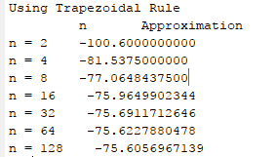

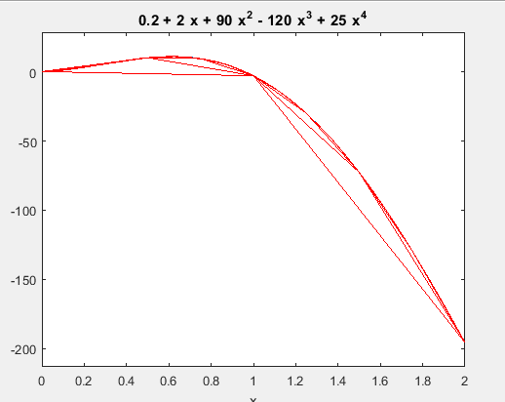

**Task 2:**

**Code:**

syms x,a,b

a = 0; b = 2;

f = @(x) 0.2 + 2.*x + 90.*x.^2 - 120.*x.^3 + 25.*x.^4;

fnew = @(x,a,b) f(((b-a)/2)*x+((b+a)/2))*((b-a)/2);

c = [1.0000 1.0000 0.0000 0.0000 0.000;

0.5555 0.8888 0.5555 0.0000 0.000;

0.3478 0.6521 0.6521 0.3478 0.000;

0.2369 0.4786 0.5688 0.4786 0.2369];

xin = [-0.5773 0.5773 0.0000 0.0000 0.000;

-0.7745 0.0000 0.7745 0.0000 0.000;

-0.8611 -0.3399 0.3399 0.8611 0.000;

0.9061 0.5384 0.000 -0.5384 -0.9061];

summ = c.*fnew(xin,a,b)

finalsum = sum(summ,2)

hold on

plot([-0.5773 0.5773],[8.8612 -88.8936])

plot([-0.7745 0.0000 0.7745],[2.1754 -2.4886 -75.2643])

plot([-0.8611 -0.3399 0.3399 0.8611],[0.6615 7.1519 -28.4496 -54.9419])

plot([0.9061 0.5384 0.000 -0.5384 -0.9061],[-40.2788 -38.5756 -1.5926 4.6100 0.2568])

hold off

for i=1:4

fprintf('n = %d, the integral is %.4f\n',i+1,finalsum(i));

end

**Output:**

